# **Predicting Ocean Temperatures: When Computer Swarms Meet Climate Science**

## **The Ocean's Crystal Ball**

Imagine trying to predict the weather not just for tomorrow, but for the next two years. Now imagine doing this for the vast expanses of our oceans, where temperature changes can influence everything from hurricane formation to global food security. This is the challenge that climate scientists face when forecasting sea surface temperatures (SST) – a task that has profound implications for agriculture, disaster preparedness, and understanding our changing planet.

Recent advances in artificial intelligence and optimization techniques have opened new doors for tackling this complex problem by combining the wisdom of swarms, inspired by how birds flock and fish school, with sophisticated computer models. We have achieved remarkable improvements in ocean temperature prediction accuracy. [1]

**Keywords :** Sea-surface temperature (SST), Time-series forecasting, ARIMA / SARIMA / SARIMAX, Exogenous variables (ENSO index, solar cycle), ETS (exponential smoothing), Prophet model, LSTM (Long Short-Term Memory), Particle Swarm Optimization (PSO), Random Search & Bayesian Optimization, Rolling-origin cross-validation, Variance Inflation Factor (VIF), Baseline models (seasonal naïve, moving average, linear trend, seasonal-trend decomposition), Forecast accuracy metrics (RMSE, MAE, MAPE)

## **The Traditional Approach and Its Limitations**

For decades, scientists have relied on mathematical models called ARIMA (AutoRegressive Integrated Moving Average) to forecast time series data like ocean temperatures. Think of these models as sophisticated pattern-recognition systems that analyze historical data to identify trends and seasonal cycles. Just as you might predict that temperatures will be warmer in summer based on past years, these models use mathematical equations to capture such patterns.

However, ocean temperatures are influenced by complex, interconnected factors. The El Niño Southern Oscillation (ENSO) cycle affects global weather patterns every few years, while solar activity follows roughly 11-year cycles. Traditional models often struggle to capture these multiple, overlapping influences simultaneously.

To address this challenge, scientists developed enhanced versions like SARIMA (Seasonal ARIMA) and SARIMAX (SARIMA with exogenous variables). These are like upgrading from a basic weather app to a sophisticated forecasting system that considers multiple climate factors. While more powerful, these models require careful fine-tuning of numerous parameters – a process traditionally done through trial and error.

## 

## **Enter the Swarm: Particle Swarm Optimization**

Here's where nature provides an elegant solution. Particle Swarm Optimization (PSO) is a computational technique inspired by the collective behavior of bird flocks or fish schools. Just as birds in a flock share information about food sources and adjust their flight paths accordingly, PSO uses a group of virtual "particles" to explore different parameter combinations and share their findings. [2]

Each particle represents a potential solution – in this case, a specific set of model parameters. The particles "fly" through the solution space, constantly updating their positions based on their own best discoveries and the best discoveries of their neighbors. This collaborative approach often finds better solutions than traditional optimization methods, much like how a flock of birds can locate food sources more efficiently than a single bird searching alone.

The mathematical foundation of PSO involves updating each particle's velocity and position using three key components:

* Inertia (W): The tendency to continue in the current direction
* Cognitive learning (c1): Attraction to the particle's own best position
* Social learning (c2): Attraction to the swarm's best-known position

## **A Multi-Model Approach to Ocean Forecasting**

The research employed three distinct approaches to harness the power of PSO for sea surface temperature prediction:

## **Approach 1: PSO-Optimized SARIMA Models**

Using a comprehensive dataset of monthly sea surface temperatures from 1900 to 2023 (1,480 data points), we applied PSO to optimize SARIMA model parameters. The algorithm tested different combinations of autoregressive terms, differencing operations, and moving averages while considering seasonal patterns.

The PSO swarm consisted of 20 particles exploring the parameter space over 20 iterations. Each particle represented a different model configuration, and the swarm collectively searched for the combination that minimized prediction errors. This approach achieved an impressive 11.44% improvement over traditional SARIMA models, reducing the root mean square error from 0.228°C to 0.202°C. [1]

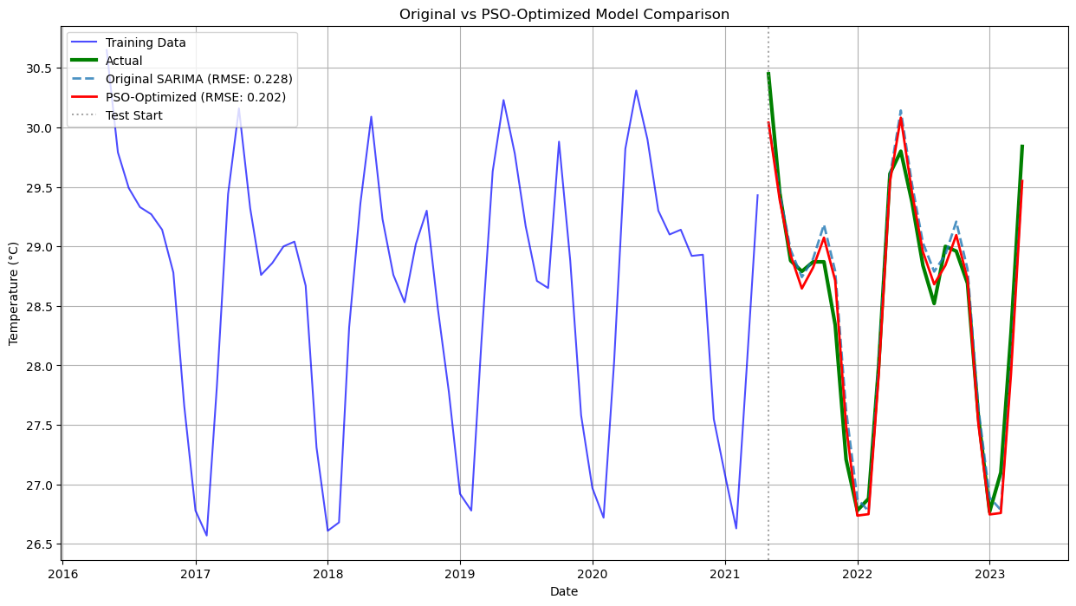

## 

## **Approach 2: PSO-Enhanced Neural Networks**

The second approach combined PSO with Long Short-Term Memory (LSTM) neural networks. LSTMs are specialized artificial neural networks designed to remember important information over long periods, crucial for capturing long-term climate patterns.

Think of an LSTM as a sophisticated memory system that can decide what information to remember, what to forget, and what to pay attention to when making predictions. The PSO algorithm optimized four key aspects of the LSTM:

* Number of memory units (10-100 range)
* Learning rate (0.0001-0.01 range)
* Batch size (8-64 range)
* Training duration (10-50 epochs)
* Outcome:
  + Baseline LSTM RMSE: 0.302 °C
  + PSO-LSTM RMSE: 0.257 °C
  + 15% error reduction.

The PSO-optimized LSTM achieved significant improvements over baseline models, with validation errors dropping from 0.303°C to 0.257°C in root mean square error terms. [3][4]

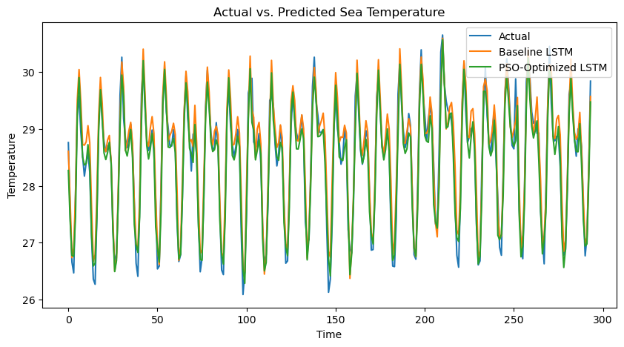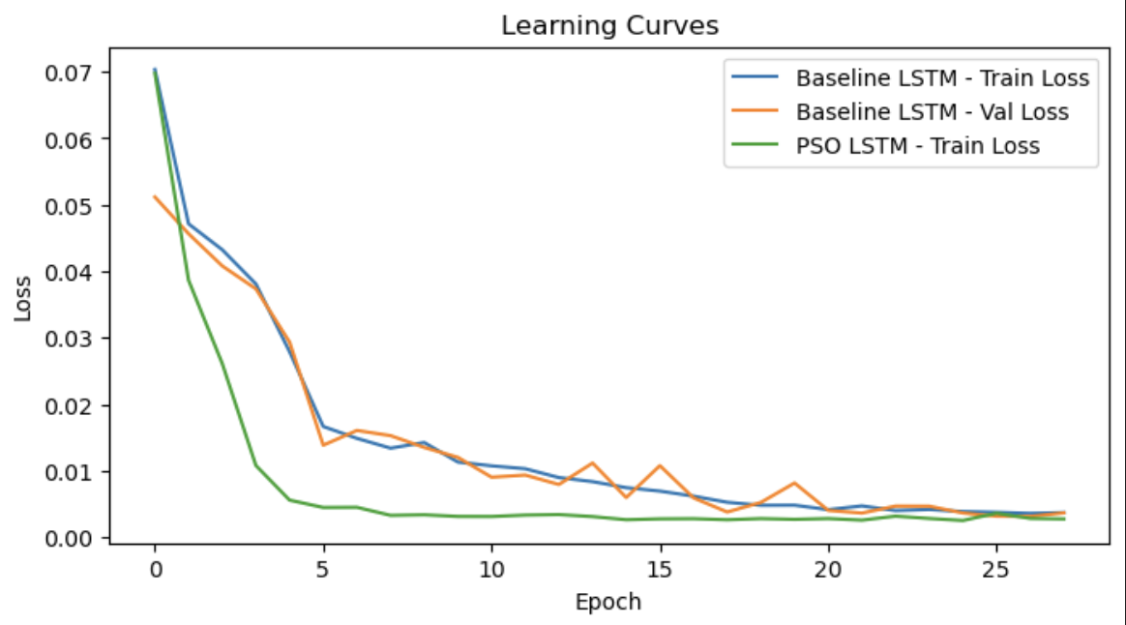

## 

## **Approach 3: (a) Comprehensive Multi-Model Framework**

The most sophisticated approach involved creating a comprehensive framework that evaluated multiple forecasting models simultaneously:

* SARIMA: Traditional seasonal time series models
* SARIMAX: Enhanced with climate indicators (ENSO and solar cycle data)
* ETS: Exponential smoothing state space models
* Prophet: Facebook's open-source forecasting tool

This framework employed advanced cross-validation techniques, testing each model's performance across six different periods to ensure robust evaluation. We have also implemented the Variance Inflation Factor (VIF) analysis to eliminate redundant climate variables that might confuse the models. VIF analysis played a very important role in eliminating the unwanted features which confused the SARIMAX model at first (RMSE ~ 8).

1. **Numerical comparison of different error metrics over different Models**

| **Model** | **MAE_mean** | **MAE_std** | **MAE_min** | **MAE_max** | **MSE_mean** | **MSE_std** | **MSE_min** | **MSE_max** | **RMSE_mean** | **RMSE_std** | **RMSE_min** | **RMSE_max** | **MAPE_mean** | **MAPE_std** | **MAPE_min** | **MAPE_max** |
| --- | --- | --- | --- | --- | --- | --- | --- | --- | --- | --- | --- | --- | --- | --- | --- | --- |
| SARIMA_PSO | 0.2717 | 0.0501 | 0.1992 | 0.3375 | 0.1078 | 0.0376 | 0.0596 | 0.1564 | 0.3233 | 0.0575 | 0.2441 | 0.3955 | 0.0095 | 0.0017 | 0.007 | 0.0117 |
| SARIMAX | 0.208 | 0.0896 | 0.1501 | 0.404 | 0.0748 | 0.0692 | 0.0331 | 0.2272 | 0.2533 | 0.1032 | 0.1819 | 0.4766 | 0.0073 | 0.0031 | 0.0053 | 0.0139 |
| ETS | 0.2622 | 0.1259 | 0.1541 | 0.4895 | 0.1145 | 0.091 | 0.0433 | 0.2836 | 0.3148 | 0.1242 | 0.2081 | 0.5325 | 0.0092 | 0.0044 | 0.0055 | 0.0173 |
| Prophet | 0.2433 | 0.1174 | 0.159 | 0.4996 | 0.1006 | 0.0986 | 0.0372 | 0.3181 | 0.2908 | 0.1267 | 0.193 | 0.564 | 0.0085 | 0.004 | 0.0056 | 0.0172 |

1. **Visual comparison of their Forecast**

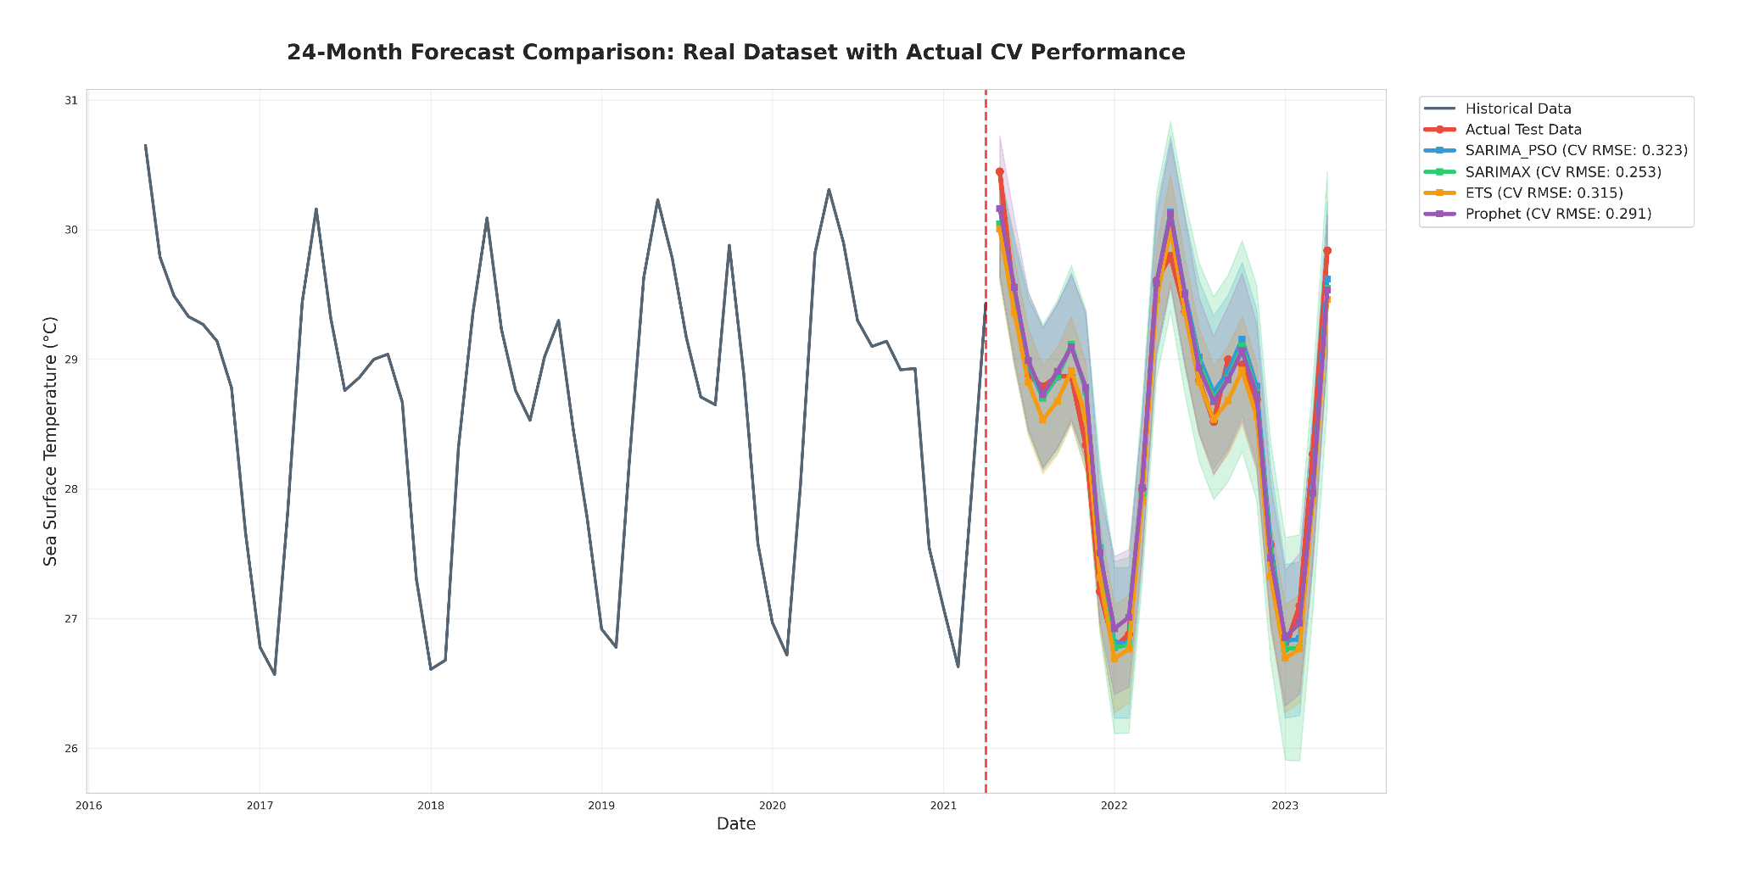

## 

## 

## **Approach 3: (b) Statistical Models Framework compared with baseline models**

| **Baseline Forecaster** | **How it works** | **RMSE (°C)** |
| --- | --- | --- |
| Seasonal Naïve | Repeats last year’s monthly values | 0.281 |
| 12-Month Moving Average | Smooths out short-term bumps | 0.263 |
| Linear Trend | Projects a straight-line fit | 0.249 |
| Seasonal Trend Decomposition | Extends linear trend with repeating seasonality | 0.238 |

## **Why the Comparison Matters**

* SARIMA (PSO) beat the best baseline by 15%.
* SARIMAX (optimised) slashed RMSE further to 0.204 °C, a 14.2% improvement over the Seasonal-Trend baseline.
* Even the best deep-learning model (PSO-LSTM) comfortably outperformed every naïve baseline.

These gaps underscore how much predictive skill is gained from both smarter algorithms *and* well-chosen climate signals like ENSO.

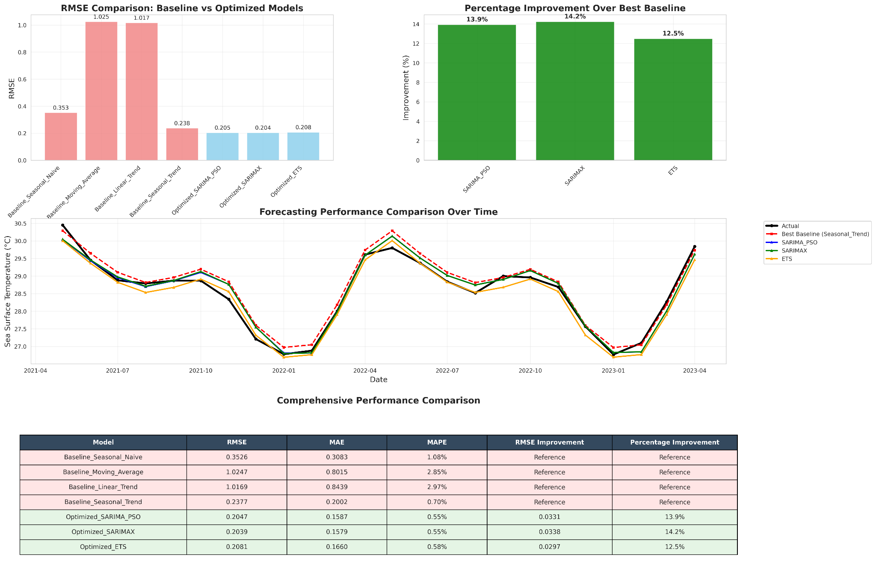

## **Breakthrough Results**

The comprehensive evaluation revealed surprising insights about ocean temperature forecasting. While PSO optimization consistently improved individual models, the choice of base model proved equally important. SARIMAX emerged as the champion, achieving the lowest prediction error of 0.253°C when incorporating climate indicators like ENSO and solar cycles.

The research demonstrated a 14.2% improvement over traditional baseline methods, with the best-performing model (SARIMAX) achieving an absolute improvement of 0.034°C in prediction accuracy. While this might seem small, such improvements can be crucial for climate applications where even small temperature changes can have significant environmental impacts.

Interestingly, the study found that simpler optimization algorithms sometimes outperformed PSO. Random search achieved competitive results in just 45 seconds compared to PSO's 252 seconds, while Bayesian optimization provided marginal improvements in 79 seconds. This highlights the importance of balancing computational efficiency with optimization quality.

* **Comparison of Optimization Algorithms (Performance vs Time)**

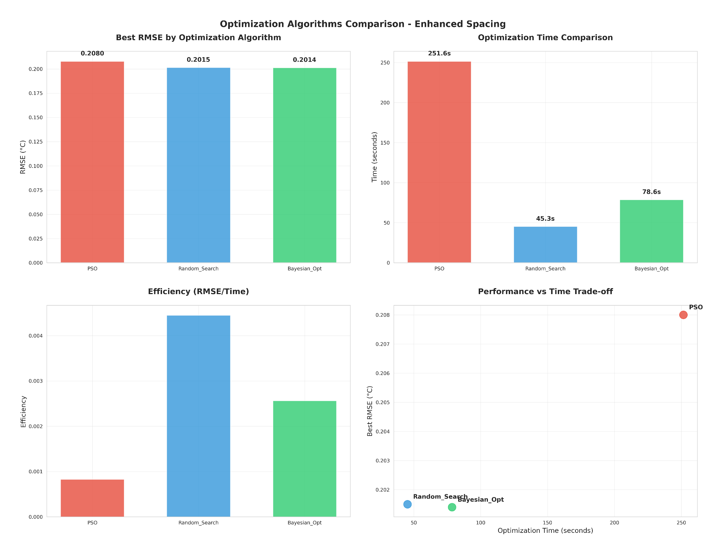

## **Real-World Applications and Implications**

These advances in ocean temperature forecasting have immediate practical applications:

Climate Monitoring: Improved predictions help scientists track climate change effects and validate global climate models. The 24-month forecast horizon provides valuable lead time for identifying emerging climate trends.

Agriculture and Food Security: Farmers and agricultural planners can better prepare for weather patterns influenced by ocean temperature changes. El Niño and La Niña events, driven by sea surface temperature variations, significantly impact global crop yields.

Disaster Preparedness: Hurricane intensity is closely linked to ocean temperatures. Better forecasting can improve early warning systems and help coastal communities prepare for extreme weather events.

Marine Ecosystems: Ocean temperature changes affect fish migration patterns, coral reef health, and marine biodiversity. Accurate predictions support conservation efforts and sustainable fisheries management.

## **Technical Innovation and Methodology**

The research showcased several methodological innovations that advance the field of time series forecasting:

Integrated Optimization Framework: The combination of multiple optimization algorithms (PSO, Random Search, Bayesian Optimization) with diverse forecasting models created a robust evaluation platform.

Sophisticated Cross-Validation: The six-fold rolling-origin cross-validation ensured that results were not dependent on specific data splits, providing confidence in the model's real-world performance.

Feature Engineering: The creation of synthetic climate indicators (ENSO Index and Solar Cycle variables) and subsequent multicollinearity analysis demonstrated the importance of careful variable selection.

Computational Efficiency Analysis: The comparison of optimization algorithms revealed important trade-offs between computational cost and performance improvement, providing practical guidance for implementation. [2][5]

## **Challenges and Future Directions**

Despite these achievements, several challenges remain. PSO optimization requires significant computational resources, and performance can be sensitive to algorithm parameters. The models also require long historical datasets for stable parameter estimation, which may not always be available for all ocean regions.

Future research directions include developing hybrid optimization approaches that combine the strengths of different algorithms, integrating deep learning techniques with traditional time series methods, and extending forecast horizons beyond the current 24-month limit.

The research also points toward real-time implementation possibilities, where models could continuously update their parameters as new data becomes available, potentially improving prediction accuracy over time.

## 

## **Conclusion: The Future of Climate Forecasting**

The integration of swarm intelligence with advanced forecasting models represents a significant step forward in climate science. By achieving a 14.2% improvement in ocean temperature prediction accuracy, this research demonstrates how computational techniques inspired by nature can enhance our understanding of complex environmental systems.

As climate change continues to pose global challenges, such improvements in forecasting accuracy become increasingly valuable. The ability to predict ocean temperatures more accurately provides scientists, policymakers, and communities with better tools for understanding and adapting to our changing planet.

The success of this multi-model, multi-optimization approach suggests that the future of climate forecasting lies not in single solutions, but in intelligent combinations of diverse techniques. Just as birds in a flock achieve better results through collaboration, the combination of different computational approaches may hold the key to unlocking more accurate and reliable climate predictions.

This research showcases how the convergence of artificial intelligence, optimization theory, and climate science can produce practical solutions for one of humanity's most pressing challenges: understanding and predicting our planet's complex climate systems.

## **References**

[1] <https://www.mdpi.com/1996-1073/13/6/1369/pdf>

[2] <https://downloads.hindawi.com/journals/mpe/2015/968067.pdf>

[3] <https://lib.jucs.org/article/82370/>

[4] <https://pmc.ncbi.nlm.nih.gov/articles/PMC10112815/>

[5] <https://www.mdpi.com/2071-1050/11/11/3096/pdf?version=1559722531>

[6] G. E. P. Box, G. M. Jenkins, and G. C. Reinsel, Time Series Analysis: Forecasting and Control, 5th ed. Hoboken, NJ, USA: Wiley, 2015.

[7] J. Kennedy and R. Eberhart, "Particle Swarm Optimization," in Proc. ICNN'95 - Int. Conf. Neural Networks, Perth, WA, Australia, 1995, pp. 1942–1948, doi: 10.1109/ICNN.1995.488968.

[8] S. Seabold and J. Perktold, "Statsmodels: Econometric and Statistical Modeling with Python," in Proc. 9th Python in Science Conf., Austin, TX, USA, 2010, pp. 57–61.

[9] J. Lavery, "pmdarima: ARIMA estimators for Python," 2018. [Online]. Available: https://alkaline-ml.com/pmdarima/

[10] L. Miranda, "PySwarms: a research toolkit for Particle Swarm Optimization in Python," 2018. [Online]. Available: https://pyswarms.readthedocs.io/

[11] S. Hochreiter and J. Schmidhuber, "Long short-term memory," Neural Computation, vol. 9, no. 8, pp. 1735–1780, Nov. 1997.